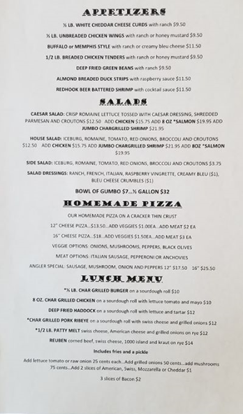
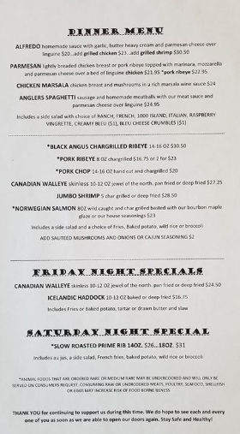
Open Wednesday ~ Sunday
Lunch ~ 11am-4pm.
Dinner~ 5pm-9pm.

